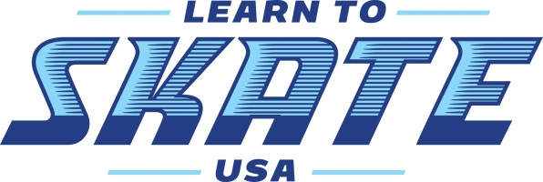@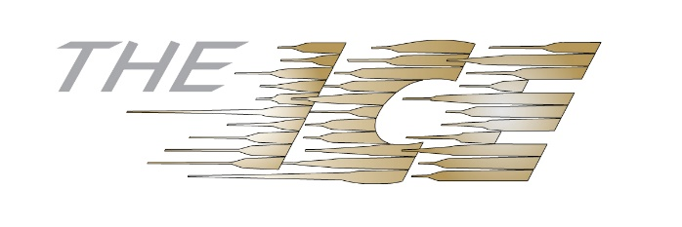
The ICE Learn to Skate Comprehensive Program Includes:
● Weekly, 30 Minute Group Instructional Class ● Skate Rental as Necessary
● Public Session Skater Pass ● Learn to Skate USA Membership
● Mid-term and End of Semester Evaluations ● Recital and Graduation!
Learn to Skate Class Level and Description:
Snow Plow Sam 1-3:
This class is for skaters who are under the age of 6. Skaters will learn the fundamentals of balance, skills and skating on their own.
Basic 1-Basic 6 and Pre-Free Skate (formerly Basic 7 & 8):
These classes are for skaters 6 years and older or have passed Snow Plow Sam 3. Skaters learn skills in a progressive manner based on the Learn to Skate USA Basic Skills Curriculum.
Hockey 1:
Specifically geared to teach skaters ages 6 years and older the skating skills and fundamentals needed to progress to the Learn to Play Hockey class.
IceMen:
Boys only!! This class is designed for male skaters who want to be in class together and learn higher level skills. This USFS program is new and is a great way to encourage boys to skate!
Freeskate 1-6:
Our coaches will help skaters earn skate badges for all of the freeskate levels including jumps, spins, and moves in the field.
Showcase Class/ Theater on ICE: This class is for skaters basic 6 and above who want to learn the fun of show skating! Be a part of this class and perform in shows at The ICE, as well as competitions. Showcase uses props, fun music and costumes
For additional details on skills, skating levels and the Learn to Skate USA curriculum -Visit https://learntoskateusa.com

